


SAVEETHA SCHOOL OF ENGINEERING

SAVEETHA INSTITUTE OF MEDICAL AND TECHNICAL SCIENCES

COMPUTER SCIENCE AND ENGINEERING PROGRAMME

LAB MANUAL CSA1305

THEORY OF COMPUTATION

COMPUTER SCIENCE AND ENGINEERING PROGRAMME

LIST OF EXPERIMENTS

- Write a C program to find ε -closure for all the states in a Non-Deterministic Finite Automata (NFA) with ε -moves
AIM:
To write a C program to find the ε-closure for all the states in a Non-Deterministic Finite Automata (NFA) with ε-moves.

Apparatus Required
- Computer/Laptop
- GCC Compiler (Turbo C/GCC/CodeBlocks/VS Code)
- C Programming Language

Algorithm
- Start the program.
- Read the number of states in the NFA.
- Read the ε-transition matrix.
- For each state, initialize its ε-closure with itself.
- Traverse all ε-transitions using Depth First Search (DFS).
- Add every reachable state through ε-transitions to the ε-closure.
- Display the ε-closure of each state.
- Stop the program.

Program Code

#include <stdio.h>

int n;

int e[10][10];

int visited[10];

void eclosure(int state)

{

int i;

visited[state] = 1;

printf("q%d ", state);

for(i = 0; i < n; i++)

{

if(e[state][i] == 1 && visited[i] == 0)

eclosure(i);

}

}

int main()

{

int i, j;

printf("Enter number of states: ");

scanf("%d", &n);

printf("Enter epsilon transition matrix:\n");

for(i = 0; i < n; i++)

{

for(j = 0; j < n; j++)

{

scanf("%d", &e[i][j]);

}

}

printf("\nEpsilon Closures:\n");

for(i = 0; i < n; i++)

{

for(j = 0; j < n; j++)

visited[j] = 0;

printf("ε-closure(q%d) = { ", i);

eclosure(i);

printf("}\n");

}

return 0;

}

Sample Input
Enter number of states: 4

Enter epsilon transition matrix:
0 1 0 0
0 0 1 0
0 0 0 1
0 0 0 0

Sample Output
Epsilon Closures:
ε-closure(q0) = { q0 q1 q2 q3 }
ε-closure(q1) = { q1 q2 q3 }
ε-closure(q2) = { q2 q3 }
ε-closure(q3) = { q3 }

OUTPUT: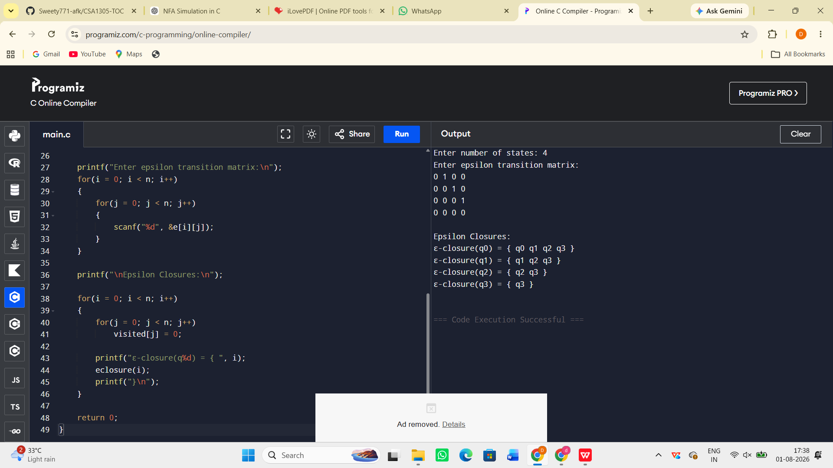

Result:
The C program to find the ε-closure for all the states in a Non-Deterministic Finite Automata (NFA) with ε-moves was successfully implemented and executed. The ε-closures of all the states were computed and displayed correctly.

